**SOURCE OF BUSINESS DISCRIMINATION IN CHINA**

**By Tian Xu and Linrui Fan**

During the past two decades, China has grown into an increasingly important sector for the world economy. At the same time, the fairness of treatment towards individual firms has become an intense topic in recent years. To understand the source of the difference in treatments, this paper will first cross analyze the output and capital wedges for sizable industrial firms located in China across the decade since 2002, and then regression estimations will be performed based on firm types and sizes. The result suggests that despite the improved openness of the markets, private firms are increasingly facing higher cost of capital financing which severely affects their investment decision and deviate China’s resource allocation from its most efficient combination.

1. **Introduction**

China has kept expanding its economy for the past decades, and it has made a huge progress that surprises the world. The country has accelerated its development especially after it joined the World Trade Organization (WTO) at the end of 2001, which gives China the access of world market and makes it the factory of the world today. As the world’s second largest economic entity, China’s growth sets a great exemplification for the world to learn. However, there are still drawbacks and unfairness existing which prevent this country’s industrial firms from allocating and utilizing their resources in the most efficient way. Critics state that while state-owned enterprises enjoy direct government subsidies and low-cost bank loans, Chinese government has employed numerous methods targeting other types of companies, including but not limited to forced technology transfer, limited market access and stricter regulations.

Some may argue that this form of discrimination can benefit economic development under China’s special economics system. However, research has showed that the difference in treatments could lead to lower economic growth, as resources can be misallocated to less productive firms resulting a smaller marginal output from the inputs. Researchers have found some quantitative evidence for this argument. For instance, Chang-Tai Hsieh and Peter J. Klenow (2009) has demonstrated that relative to US, China has a larger variance for its wedge distribution, a measurement for fairness of treatment developed by V. V. Chari, Patrick J. Kehoe and Ellen R. McGrattan (2006). Through smoothing the wedges distribution to US level (fairer treatment for the firms), China could potentially realize 30% to 50% of productivity gain. There is also evidence shows that Chinese government has started to transform a large number of firms under state control and privatize or close a bunch of small state-owned firms, and Chang-Tai Hsieh and Zheng (Michael) Song (2015) has demonstrated that this transformation has helped the total factor productivity (TFP) of state-owned firms to catch up with that of the private firms, though the capital productivity of state-owned firms is still lower than that of the private ones. These phenomena have clarified that reducing the unfairness in the industry and accelerating resource reallocation is essential for the future economic growth.

The goal of this paper is to build upon these findings and study the sources of the differences in treatment for firms operating in China. In short summary, our results suggest that although on average the level of deviation from efficient allocation has decreased, private firms have increasingly deviated from their optimal allocation potentially due to unfair treatments from the overall business environment. The results also suggest that the source of problem is not about the entry obstacle or openness of the market. Instead, private firms’ main burden is the lack of capital and the limited access of capital financing.

The rest of the paper will be divided in six sections. We will first examine the two wedges and the dataset that we will use for analyzing the level of treatment in Section II and then compute the wedges for individual firm across the time period in Section III. We then compare the results based on firms’ ownership types in Section IV and then based on revenue size in Section V. Finally, we will run a multi-variable regression with dummy variables in Section VI and gives our conclusion in Section VII.

1. **Introduction to methods and dataset**

To help understand our research results, this section provides a brief introduction to the calculation of firm-level wedges developed by V. V. Chari, Patrick J. Kehoe and Ellen R. McGrattan (2006) and the reason why it is an effective tool for measuring special treatment level.

In an ideal economic model without any external influences, a firm should be able to choose its optimal choice of labor and capital given by its inputs. For instance, given the firm’s Cobb-Douglas production function and profit function1[1]:

Through rearrangement of first order conditions, we will get:

$$\frac{L}{K}=\frac{(1-a)R}{aw}$$

Given by this function, firm should always be able to choose an optimal allocation of resources as long as it observes the price value of its inputs. However, in reality, firms’ resources allocation often deviates from the optimal value suggested by the formula. Various invisible costs introduced through government and financial regulations can account for this deviation. Firms cannot explore and utilize their resources very efficiently if they also need to deal with the deviations caused by the external costs and extra pressure from government. Thus, understanding where and how much those costs and regulations affect the firms is necessary for us to realize the improvement we can make on the efficiency of resource allocation.

Previous research suggests two external forces for the firms to consider; one is the invisible cost when selling the products, and the other is the extra cost for capital financing. To measure the deviation, consider the normal Cobb-Douglas-Function and a modified firm-profit function:

$$Y=ZK^{a}L^{1-a}$$

$$π=\left(1-τ_{y}\right)PY-wL-\left(1+τ_{k}\right)RK$$

Compared with the normal profit function, two variables are introduced to stand for firm-level wedges: $τ_{y}$ and $τ_{k}$. $τ_{y}$ can be interpreted as an output wedge, which can be affected through government regulation and limited market access. $τ_{k}$ is the capital wedge that can account for the difference in costs for firms’ capital financing. For an ideal economy, both $τ_{y}$ and $τ_{k}$ should be 0, suggesting no deviations from efficient allocations for any firms.

Based on these two equations, we can get the firm’s optimal choice for its capital and labor through first order equations and compute the formula for each wedge:

With respect to K: $\left(1-τ_{y}\right)PZ{a\left(\frac{K}{L}\right)}^{a-1}=\left(1+τ_{k}\right)R$ (1)

With respect to L: $\left(1-τ_{y}\right)PZ{\left(1-a\right)\left(\frac{K}{L}\right)}^{a}=w$ (2)

$\left(1-τ_{y}\right)PZ{\left(1-a\right)\left(\frac{K}{L}\right)}^{a}L=w$ L

$\left(1-τ_{y}\right)=\left(1-a\right)\frac{wL}{PY}$

Dividing (1) and (2): $\left(1+τ_{k}\right) = \frac{a}{1-a}\frac{wL}{RK}$

Based on the equations we have, we can see that to calculate the wedges, three components for the firms are needed: wL (total wage paid), RK (opportunity cost of the capital) and PY (revenue or value added for industrial firms). Also, in order to demonstrate the combined effects of the two wedges, we will use the formula employed by Chang-Tai Hsieh and Peter J. Klenow (2009):

$$\frac{{(1+τ_{k})}^{a}}{1-τ_{y}}$$

Aside from the theoretical equations, the dataset that we will use is the China Industrial Survey from 2002 to 2012 collected by the China Statistics Bureau (excluding 2009 and 2010 due to missing data), which included important accounting indexes for industrial firms above designated size. Before 2011, the standard is set for firms with over 5 million yuan in annual sales. After 2011, the standard is re-adjusted to 20 million yuan. The reason we choose this time period is because it is arguably the most important decade in China’s economic development with the WTO entry at the end of 2001 and also the stimulus program in 2008.

The raw data contains a large number of firms. However, because the information is reported by the firms themselves, data could be polluted as firms may not follow the exact accounting procedure. In this case, we follow the standard set [2] by Rudai Yang, Ting Jiang, and Huihua Nie (2012), which eliminate the majority of abnormal observations. Variables that we will use for calculations are the total capital, total wage paid, and total value added. In certain years, total value added is missing and, in that case, we will estimate the value-added by dividing value-added tax with the tax rate for respective year. For the opportunity cost rate R, we use the average business interest rate at 6.5% and assume every firm shares the same rate. As for the share of capital $a$, we get the value from Penn World Table 9.1, which included the value of China’s labor compensation share during this time period. For the classification of the firms, we use the register type code in the dataset to determine the exact type of the firms. As for the sizes, we use the standard set by the Chinese government, which defines firms with less than 25 million yuan annual revenue as small industrial firms, firms with less than 300 million yuan annual revenue as medium industrial firms, and firms with over 300 million yuan annual revenue as large industrial firms.

1. **General Picture**

Table 1 shows the means and standard deviations of output wedges and capital wedges from 2002 to 2012 (excluding 2009 and 2010). As the table shows, in general both the output wedge and capital increases steadily from 2002 to 2008. For the output wedge, the value increases from 0.380 in 2002 to 0.475 in 2008. The increase is more aggressive for the capital wedge, increasing from 0.846 in 2002 to 1.44 in 2008. As for the standard deviations, both capital wedge and output wedge have increased along with the means. The standard deviations for output wedge increase from 0.305 in 2002 to 0.375 in 2008, while the standard deviations for capital wedge increase from 0.596 in 2002 to 1.09 in 2008.

This result suggests that during this time period, firms in China on average had experienced mixed treatments in terms of its business environment. On one hand, output wedge has grown by 24.7% and gotten closer to 1 (the ideal value), suggesting that the firms in general have enjoyed less regulation and obstacles when selling the products. On the other hand, the capital wedge has increased by almost 71%, suggesting increasingly limited access for capital. The capital wedges of the first two years are less than 1 suggesting a potential of over expansion during that time period. After that, we notice a sudden jump from 2003 to 2004 for capital wedge which is the largest increase for a single in our dataset, and we suspect it may correspond with the end of state-owned-enterprises reform that began in 1998. During the reform stage, many medium size state-owned-enterprises with severe loss were transferred to private hands. After the transfer, many owners chose to reduce the production and shift their business focus to more profitable industries. Mathematically, this would reduce K and caused the increase in capital wedge. Nevertheless, the exact reason will require future research. The second largest increase happened in 2008. We believe this increase is caused by the financial crisis that forced the banks to collect more loans and made it more expensive for firms to expand productions. Overall, the data suggest that while the market has become more open for the firms to operate, cost for capital financing has gradually increased during this period.

However, the trend shifts again in 2011. While the output wedge still increases at a steady level, the capital wedge decreases compared with 2010. We suspect this decrease is correlated with the Chinese economic stimulus program that began at the end of 2008, which ingested over 4 trillion yuan to the market and helped expand the infrastructure and capital investment. The overflow of cash may helped ease firms’ financial burdens especially for those participate in construction business, but this statement requires more evidence from future research. Due to the lack of data, we were unable to calculate both wedges for recent years. However, from the recent government policies, we estimate that capital wedge will increase again from the “cutting production” movement that began in 2017 and the output wedge will continue to get closer to 1 as a new stage of SOE reforms started.

**Table 1**

|  |  |  |  |  |  |  |  |
| --- | --- | --- | --- | --- | --- | --- | --- |
|  | **2002** | **2003** | **2004** | **2005** | **2006** | **2007** | **2008** |
| Output Wedge Mean | 0.380 | 0.374 | 0.395 | 0.420 | 0.429 | 0.435 | 0.474 |
| Output Wedge SD | 0.305 | 0.298 | 0.250 | 0.341 | 0.341 | 0.340 | 0.375 |
| Capital Wedge Mean | 0.846 | 0.868 | 1.083 | 1.103 | 1.167 | 1.254 | 1.447 |
| Capital Wedge SD | 0.596 | 0.617 | 0.757 | 0.806 | 0.848 | 0.921 | 1.099 |

|  |  |  |
| --- | --- | --- |
|  | **2011** | **2012** |
| Output Wedge Mean | 0.519 | 0.528 |
| Output Wedge SD | 0.441 | 0.437 |
| Capital Wedge Mean | 1.334 | 1.282 |
| Capital Wedge SD | 1.018 | 0.969 |

Table 2 shows the wedge TFPQ distribution $\frac{{(1+τ_{k})}^{a}}{1-τ_{y}}$ for the same time period and Graph 1 depicts the wedge TFPQ distribution for 2002, 2008 and 2012. The mean for TFPQ increases from 3.509 in 2002 to 3.578 and decreases 3.299 in 2012. Although there’s slight change over the years, we believe the change is within the reasonable range. However, while the average stays relatively steady, the standard deviations for the wedge TFPQ increases from 2.159 in 2002 to 2.572 in 2012 despite the relatively steady mean changes during the time period. As Restuccia and Rogerson (2008) suggested, different treatment for individual firm will likely cause misallocation of capital and caused a lower marginal output and TFP, and this result suggested that when combining the wedges together, firms in China overall has face increasingly different treatments when participating in business activities. In the long run, this kind of discrimination will restrain China’s productivity growth. The two likely causes of discrimination will be examined in later sections.

**Table 2**

|  |  |  |  |  |  |  |  |
| --- | --- | --- | --- | --- | --- | --- | --- |
|  | **2002** | **2003** | **2004** | **2005** | **2006** | **2007** | **2008** |
| TFPQ Mean | 3.509 | 3.580 | 3.283 | 3.528 | 3.514 | 3.577 | 3.578 |
| TFPQ SD | 2.159 | 2.195 | 1.788 | 2.234 | 2.238 | 2.321 | 2.447 |

|  |  |  |  |  |
| --- | --- | --- | --- | --- |
|  | | | **2011** | **2012** |
| TFPQ Mean | | | 3.394 | 3.299 |
| TFPQ SD | | | 2.598 | 2.572 |
|  | | |  |  |
|  |  |

1. **Wedges based on Types**

Table 3 to 7 show the means and standard deviations of output wedges, capital wedges, and wedge TFPQs of firms from 2002 to 2012 (again excluding 2009 and 2010), categorizing firms by state-owned-enterprises (SOE), private, HK-Macau-Taiwan (HKT), foreign, and other respectively. In general, we can observe a steady increase on output wedges for all five types of firms from 2002 to 2007 and a sudden jump starting at the year of 2008. Firms from Hong Kong, Macau, and Taiwan have the most output wedges increase from 0.391 to 0.595. The changes for capital wedges, however, has increased from 2002 to 2008 and them started to decrease after 2008.

The increase on output wedges suggests, as mentioned beforehand, that firms are experiencing less regulations and obstacles for their business. The sudden jump at 2008 indicates a huge progress on giving the firms less constraints and letting them to have more freedom doing business. The increase for the private and state-owned firms are the around 10% while for other types of firms is less but still a considerable 5%. Even though all the firms enjoy a freer regulation, it is easy to see the mismatch here that firms from mainland gained more benefits from the regulation changes.

The increase on capital wedges from 2002 to 2008 also matched the previous observation despite of the various types of firms, and this pattern corresponds to the firm transformations from state-owned to private and the financial crisis in 2008, which both resulted in a more expensive capitals financing and less capital to dispose as analyzed before. Fortunately, firms did not suffer too long from the increasingly expensive capitals because the capital wedges are observed a decrease after 2008, and we can see this as an effective recovery from the damages caused by the financial crisis. Despite of the general policy stimulus the firms experienced after 2008, the disparity observed on output wedges also exists on capitals. The state-owned and private firms have recovered faster than other types of firms. Their average capital wedge from 2012 has decreased roughly to the same level as 2007, while the capital wedge for other firms is still higher than their 2007 level.

We also see some changes for the difference of capital wedges across the firms types during that decade. In earlier years, foreign and HKT firms’ capital wedges are lower than both private and SOEs’, which may suggest an overall encouraging environment for foreign firms to invest in China. However, as time goes SOE’s capital wedge “surpasses” other firms and becomes the lowest for almost every single year after 2006, suggesting another China’s policy shift and re-focus on capital investment through SOEs expansion.

The wedge TFPQ distribution for all types of firms hold pretty steady with slight fluctuate between each year but the overall changes are not substantial. The overall increase on the standard deviation can also be observed but only among state-owned and private firms. From this we can see that even though mainland firms are treated better on regulations, the treatments for the individual firms of these two types are the most different ones. This could be the reason why China still faces a relative severe misallocation of capital and the consequential lower marginal output.

**Table 3 (SOE)**

|  |  |  |  |  |  |  |  |
| --- | --- | --- | --- | --- | --- | --- | --- |
|  | **2002** | **2003** | **2004** | **2005** | **2006** | **2007** | **2008** |
| Output Wedge Mean | 0.378 | 0.372 | 0.372 | 0.392 | 0.401 | 0.407 | 0.449 |
| Output Wedge SD | 0.301 | 0.297 | 0.242 | 0.326 | 0.328 | 0.322 | 0.361 |
| Capital Wedge Mean | 0.811 | 0.839 | 0.987 | 0.999 | 1.06 | 1.14 | 1.33 |
| Capital Wedge SD | 0.578 | 0.602 | 0.719 | 0.769 | 0.809 | 0.879 | 1.06 |
| TFPQ Mean | 3.47 | 3.56 | 3.37 | 3.63 | 3.60 | 3.63 | 3.61 |
| TFPQ SD | 2.12 | 2.18 | 1.81 | 2.25 | 2.24 | 2.31 | 2.43 |

|  |  |  |
| --- | --- | --- |
|  | **2011** | **2012** |
| Output Wedge Mean | 0.509 | 0.520 |
| Output Wedge SD | 0.437 | 0.433 |
| Capital Wedge Mean | 1.21 | 1.16 |
| Capital Wedge SD | 1.96 | 0.930 |
| TFPQ Mean | 3.31 | 3.17 |
| TFPQ SD | 2.55 | 2.48 |

**Table 4 (Private)**

|  |  |  |  |  |  |  |  |
| --- | --- | --- | --- | --- | --- | --- | --- |
|  | **2002** | **2003** | **2004** | **2005** | **2006** | **2007** | **2008** |
| Output Wedge Mean | 0.389 | 0.376 | 0.409 | 0.430 | 0.434 | 0.441 | 0.480 |
| Output Wedge SD | 0.298 | 0.291 | 0.248 | 0.336 | 0.333 | 0.334 | 0.371 |
| Capital Wedge Mean | 0.949 | 0.924 | 1.17 | 1.20 | 1.24 | 1.34 | 1.51 |
| Capital Wedge SD | 0.622 | 0.630 | 0.771 | 0.825 | 0.861 | 0.939 | 1.11 |
| TFPQ Mean | 3.55 | 3.62 | 3.27 | 3.55 | 3.56 | 3.63 | 3.61 |
| TFPQ SD | 2.14 | 2.18 | 1.77 | 2.22 | 2.24 | 2.33 | 2.47 |

|  |  |  |
| --- | --- | --- |
|  | **2011** | **2012** |
| Output Wedge Mean | 0.515 | 0.521 |
| Output Wedge SD | 0.431 | 0.430 |
| Capital Wedge Mean | 1.41 | 1.33 |
| Capital Wedge SD | 1.04 | 0.981 |
| TFPQ Mean | 3.57 | 3.47 |
| TFPQ SD | 2.67 | 2.79 |

**Table 5 (HKT)**

|  |  |  |  |  |  |  |  |
| --- | --- | --- | --- | --- | --- | --- | --- |
|  | **2002** | **2003** | **2004** | **2005** | **2006** | **2007** | **2008** |
| Output Wedge Mean | 0.391 | 0.387 | 0.425 | 0.463 | 0.492 | 0.496 | 0.519 |
| Output Wedge SD | 0.333 | 0.320 | 0.271 | 0.384 | 0.384 | 0.391 | 0.408 |
| Capital Wedge Mean | 0.795 | 0.832 | 1.05 | 1.08 | 1.21 | 1.26 | 1.44 |
| Capital Wedge SD | 0.594 | 0.629 | 0.777 | 0.814 | 0.880 | 0.942 | 1.11 |
| TFPQ Mean | 3.41 | 3.41 | 3.02 | 3.14 | 3.09 | 3.17 | 3.25 |
| TFPQ SD | 2.15 | 2.18 | 1.69 | 2.15 | 2.08 | 2.18 | 2.29 |

|  |  |  |
| --- | --- | --- |
|  | **2011** | **2012** |
| Output Wedge Mean | 0.584 | 0.595 |
| Output Wedge SD | 0.484 | 0.469 |
| Capital Wedge Mean | 1.33 | 1.36 |
| Capital Wedge SD | 1.03 | 1.02 |
| TFPQ Mean | 2.77 | 3.73 |
| TFPQ SD | 2.23 | 2.16 |

**Table 6 (Foreign)**

|  |  |  |  |  |  |  |  |
| --- | --- | --- | --- | --- | --- | --- | --- |
|  | **2002** | **2003** | **2004** | **2005** | **2006** | **2007** | **2008** |
| Output Wedge Mean | 0.347 | 0.355 | 0.387 | 0.431 | 0.440 | 0.440 | 0.466 |
| Output Wedge SD | 0.329 | 0.322 | 0.272 | 0.385 | 0.386 | 0.381 | 0.407 |
| Capital Wedge Mean | 0.718 | 0.760 | 0.970 | 0.994 | 1.06 | 1.12 | 1.26 |
| Capital Wedge SD | 0.554 | 0.582 | 0.756 | 0.770 | 0.823 | 0.872 | 1.02 |
| TFPQ Mean | 3.74 | 3.68 | 3.27 | 3.37 | 3.36 | 3.44 | 3.46 |
| TFPQ SD | 2.35 | 2.35 | 1.87 | 2.28 | 2.30 | 2.36 | 2.43 |

|  |  |  |
| --- | --- | --- |
|  | **2011** | **2012** |
| Output Wedge Mean | 0.536 | 0.547 |
| Output Wedge SD | 0.472 | 0.464 |
| Capital Wedge Mean | 1.23 | 1.26 |
| Capital Wedge SD | 0.959 | 0.941 |
| TFPQ Mean | 2.97 | 2.94 |
| TFPQ SD | 2.37 | 2.33 |

**Table 7 (other)**

|  |  |  |  |  |  |  |  |
| --- | --- | --- | --- | --- | --- | --- | --- |
|  | **2002** | **2003** | **2004** | **2005** | **2006** | **2007** | **2008** |
| Output Wedge Mean | 0.427 | 0.368 | 0.407 | 0.419 | 0.418 | 0.432 | 0.459 |
| Output Wedge SD | 0.370 | 0.274 | 0.291 | 0.332 | 0.329 | 0.360 | 0.376 |
| Capital Wedge Mean | 0.944 | 0.843 | 1.10 | 1.14 | 1.16 | 1.25 | 1.47 |
| Capital Wedge SD | 0.594 | 0.590 | 0.725 | 0.801 | 0.820 | 0.931 | 1.18 |
| TFPQ Mean | 3.66 | 3.43 | 3.41 | 3.73 | 3.75 | 3.77 | 3.77 |
| TFPQ SD | 2.26 | 1.88 | 1.86 | 2.41 | 2.42 | 2.49 | 2.53 |

|  |  |  |
| --- | --- | --- |
|  | **2011** | **2012** |
| Output Wedge Mean | 0.496 | 0.528 |
| Output Wedge SD | 0.438 | 0.465 |
| Capital Wedge Mean | 1.33 | 1.23 |
| Capital Wedge SD | 1.03 | 0.980 |
| TFPQ Mean | 3.65 | 3.54 |
| TFPQ SD | 2.72 | 2.79 |

1. **Wedges based on Firms Sizes**

Table 8 to 10 show the means and standard deviations of output wedges, capital wedges, and wedge TFPQs of firms divided into three different sizes. The changes of capital wedge are still consistent with previous observations, with an increase from 2002 to 2008 and a decrease or stable state after it. But the changing pattern for output wedges seems not so accordant especially for small firms. An obvious plummet on output wedge means is noticed from 2003 to 2004 and the value suddenly jumped back for 2005. After the year 2005, the changing pattern of output wedge means starts to vary by firm size.

The output wedge means for medium and large firms show a clear rise after 2005, but for small firms it is a decrease again in 2007 and 2012. The plummet of output wedges and the sudden jump of capital wedges in 2004 can be seen as a consequence of the reform of the state-owned enterprises when small sized firms experienced a severe loss, with 30.9% for small firms but only 7.5% and 11.8% for medium and big enterprises. Further, since small firms have relative few capitals and thus limited capability to deal with adversity, they got struck again in 2007 and 2008 because of the financial crisis while the medium and large firms still enjoy the increase on their output wedges with less regulations and obstacles.

The wedge TFPQ distribution is changing steadily and is observed to have an increase from 2.02 to 2.32 for small firms and decrease for medium (3.39 to 2.30) and big firms (3.82 to 3.45). This means that small firms keep suffering from their previous adversity while they are treated with less attention that they should get, and the larger firms are treated with significantly more importance. The standard deviations of the TFPQ show a decrease for small (1.57 to 1.22) and medium firms (2.07 to 1.68) and an increase for large firms (2.27 to 2.65). This indicates that individual small and medium firm is treated more equally within their groups. The sad news is the differences on treatments for big companies are growing. Since they contribute the most to the overall productivity of China, this increase in disparity is most likely a restraint to China’s economic growth.

**Table 8 (Small)**

|  |  |  |  |  |  |  |  |
| --- | --- | --- | --- | --- | --- | --- | --- |
|  | **2002** | **2003** | **2004** | **2005** | **2006** | **2007** | **2008** |
| Output Wedge Mean | 0.638 | 0.631 | 0.436 | 0.717 | 0.757 | 0.614 | 0.672 |
| Output Wedge SD | 0.403 | 0.397 | 0.251 | 0.424 | 0.443 | 0.425 | 0.430 |
| Capital Wedge Mean | 0.835 | 0.870 | 1.23 | 1.12 | 1.17 | 0.956 | 1.19 |
| Capital Wedge SD | 0.649 | 0.663 | 0.778 | 0.819 | 0.859 | 0.849 | 1.06 |
| TFPQ Mean | 2.02 | 2.11 | 3.09 | 2.03 | 2.01 | 2.24 | 2.08 |
| TFPQ SD | 1.57 | 1.68 | 1.67 | 1.67 | 1.68 | 1.74 | 1.94 |

|  |  |  |
| --- | --- | --- |
|  | **2011** | **2012** |
| Output Wedge Mean | 0.719 | 0.566 |
| Output Wedge SD | 0.528 | 0.342 |
| Capital Wedge Mean | 1.21 | 1.22 |
| Capital Wedge SD | 0.746 | 0.883 |
| TFPQ Mean | 2.24 | 2.32 |
| TFPQ SD | 1.30 | 1.22 |

**Table 9 (Medium)**

|  |  |  |  |  |  |  |  |
| --- | --- | --- | --- | --- | --- | --- | --- |
|  | **2002** | **2003** | **2004** | **2005** | **2006** | **2007** | **2008** |
| Output Wedge Mean | 0.401 | 0.399 | 0.369 | 0.451 | 0.465 | 0.480 | 0.526 |
| Output Wedge SD | 0.304 | 0.299 | 0.245 | 0.339 | 0.337 | 0.338 | 0.375 |
| Capital Wedge Mean | 0.933 | 0.966 | 0.995 | 1.22 | 1.29 | 1.39 | 1.58 |
| Capital Wedge SD | 0.615 | 0.637 | 0.724 | 0.823 | 0.866 | 0.940 | 1.12 |
| TFPQ Mean | 3.39 | 3.43 | 3.43 | 3.34 | 3.27 | 3.25 | 3.19 |
| TFPQ SD | 2.07 | 2.09 | 1.86 | 2.08 | 2.03 | 2.06 | 2.14 |

|  |  |  |
| --- | --- | --- |
|  | **2011** | **2012** |
| Output Wedge Mean | 0.633 | 0.668 |
| Output Wedge SD | 0.448 | 0.442 |
| Capital Wedge Mean | 1.47 | 1.39 |
| Capital Wedge SD | 1.04 | 0.983 |
| TFPQ Mean | 2.55 | 2.30 |
| TFPQ SD | 1.88 | 1.68 |

**Table 10 (Large)**

|  |  |  |  |  |  |  |  |
| --- | --- | --- | --- | --- | --- | --- | --- |
|  | **2002** | **2003** | **2004** | **2005** | **2006** | **2007** | **2008** |
| Output Wedge Mean | 0.325 | 0.320 | 0.282 | 0.371 | 0.382 | 0.388 | 0.414 |
| Output Wedge SD | 0.287 | 0.280 | 0.220 | 0.338 | 0.339 | 0.338 | 0.365 |
| Capital Wedge Mean | 0.686 | 0.706 | 0.582 | 0.929 | 1.01 | 1.11 | 1.29 |
| Capital Wedge SD | 0.521 | 0.543 | 0.483 | 0.748 | 0.798 | 0.879 | 1.06 |
| TFPQ Mean | 3.82 | 3.90 | 3.70 | 3.82 | 3.84 | 3.92 | 4.03 |
| TFPQ SD | 2.27 | 2.33 | 2.02 | 2.41 | 2.44 | 2.53 | 2.69 |

|  |  |  |
| --- | --- | --- |
|  | **2011** | **2012** |
| Output Wedge Mean | 0.504 | 0.507 |
| Output Wedge SD | 0.438 | 0.433 |
| Capital Wedge Mean | 1.32 | 1.27 |
| Capital Wedge SD | 1.01 | 0.967 |
| TFPQ Mean | 3.51 | 3.45 |
| TFPQ SD | 2.66 | 2.65 |

1. **Regression**

To study the combined effects from firms’ types and sizes on wedges and also eliminate the influence from the correlation between these two variables, we decide to run a multivariable regression capital wedge and output wedge on the dummy variables. We use the following model for our regression:

$$Y_{i}=β_{0}+{β_{1}foreign}_{i}+{β_{2}private}_{i}+{β_{3}hkt}_{i}+{β_{4}small}_{i}+{β_{5}medium}_{i}+α+ε_{i}$$

where all the independent variables are dichotomous variables that will equal to 1 if the firm is that specific type or size and 0 otherwise. To avoid multi-linearity issue, we use state-owned large enterprises as our benchmark.

Table 11 in the Appendix shows the regression of output wedge from 2002 to 2012. We notice that compared with the state-owned enterprise, foreign firms and the firms from HKT have a higher output wedges. While the private firms also held an advantage over state-owned-enterprises in earlier years, those advantage is immediately lost after 2008.

Compared with the type, the size of a firm seems to have a larger effect on its output wedge. Compared with the large firm with over 300 million yuan in annual revenue, firms with smaller size have a much larger output wedge. Potential reasons may include but are not limited to the flatter structure of smaller firms and the mobility to quickly shift focusing area. While a business adventure or investment proposal may require numerous decision processes among a large number of shareholders, those decisions in small firms are often made by at most several owners alone. The shortening may increase the risk of failure, but it certainly ensures a higher mobility for switching business practices. However, due to the change in China accounting procedure, the number of small firms in our sample has decreased significantly after 2007 (from several hundred to only around dozens). Therefore, our estimates for small firms could be statistically insignificant.

Table 12 in the Appendix shows the regression result for capital wedges on the same independent variables. Compared with the results from output wedge, we found that the characteristics of the firms have a much larger effect on the capital wedge. not only the size of a firm has an effect on its capital wedge, but the type of a firm also has a significant effect especially in recent years. More specifically, it appears that firms with firms with less revenue tends to have a larger capital wedge. For the four types, state-owned enterprises have the lowest capital wedge, suggesting the lowest cost for capital financing. Among the remaining three, foreign firms have slightly larger capital wedge than SOEs have, while the capital wedges for private firms and firms from HKT are higher with private firms suffering the highest capital cost for most of the years. More importantly, the divergence is growing in recent years, implying that compared with the other firms, the capital cost for SOE is significantly lower.

Finally, we run the regression of wedge TFPQ on firms’ characteristics in Table 13. The results show that the size of the firm has the largest effect on its TFPQ value, with the smaller firms enjoying a lower TFPQ compared with the larger one. For the effects from firms’ types, we notice that compared with the other three main types, private firms are not experiencing the same level of decrease in TFPQ value. Based on the results from the earlier two regressions, we believe that this growing burden for private firm mainly comes from the growing cost for capital financing, proved by the growing regression coefficient of capital wedge on firm’s types.

1. **Conclusion**

This paper attempts to use quantitative methods to examine the fairness of treatments towards firms in China. Overall, we found that although on average firms in China enjoy less obstruction in running business, the level of unfairness is actually increasing. In particular, discrimination towards private firms are increasing in later years.

Our analysis shows that the source of discrimination is not the obstruction for market entry, which is proven by the higher output wedge for private firms. Instead, the capital wedge shows that private firms are discriminated during the capital financing process, as private firms are not given enough capital for their production. This result corresponds with the prevalent feelings among Chinese business owners and data from Chinese government. For instance, reports from Chinese Academy of Fiscal Sciences have suggested that compared with state firms, the interest rate for private firms on average is about 1.5% higher. Considering relatively low profit margin for private firms, this increase in interest rate is further constraining private firms’ interest in investment.

Because of the age of our dataset, we can’t conclude that this will sill be the case for today’s China. Nevertheless, the trend is not likely to be shifted in six years. Although more work is needed to examine the best method for improving the overall business environment for the enterprises, Chinese government needs to focus more on the financial system reform to ensure that firms are treated equally in receiving funds and not be discriminated based on their types.

**Appendix:**

**Table 11**

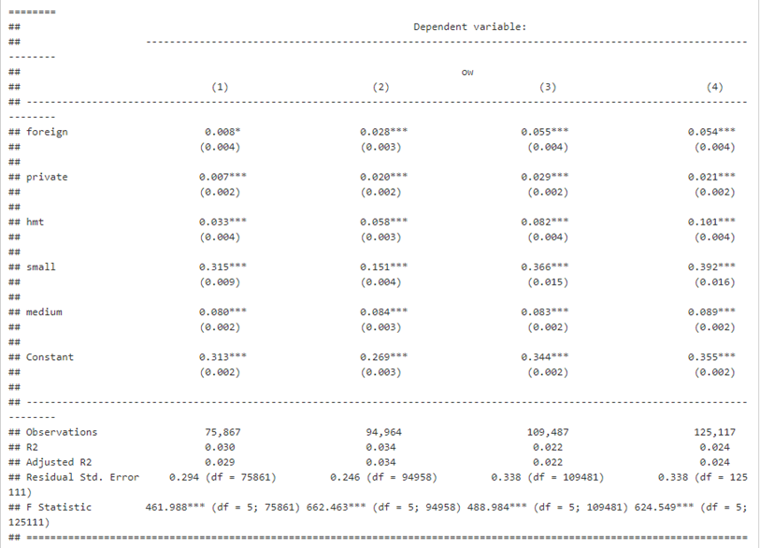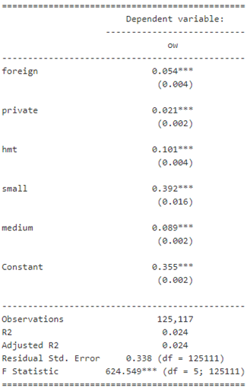

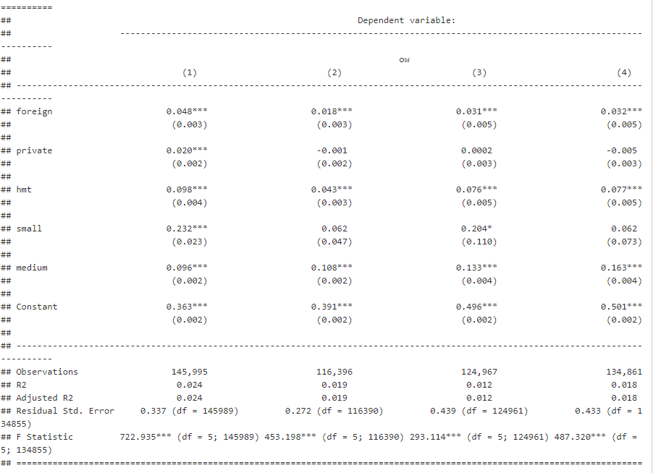

**Table 12**

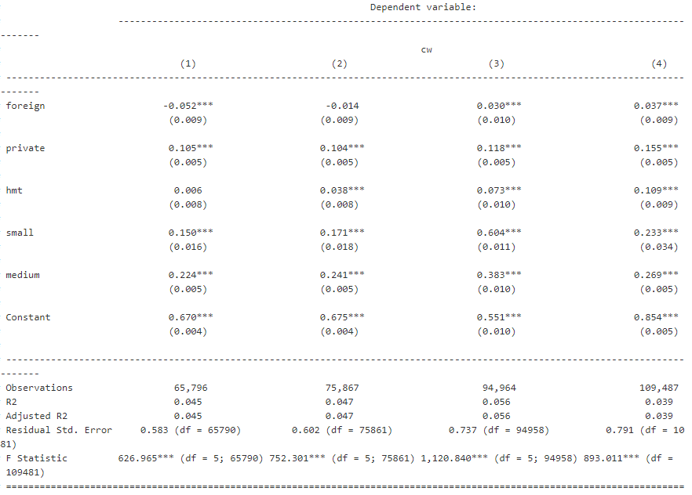

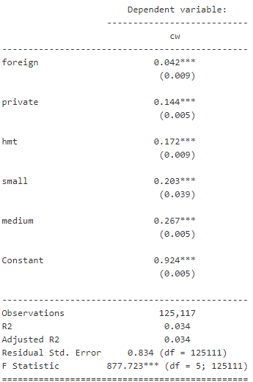

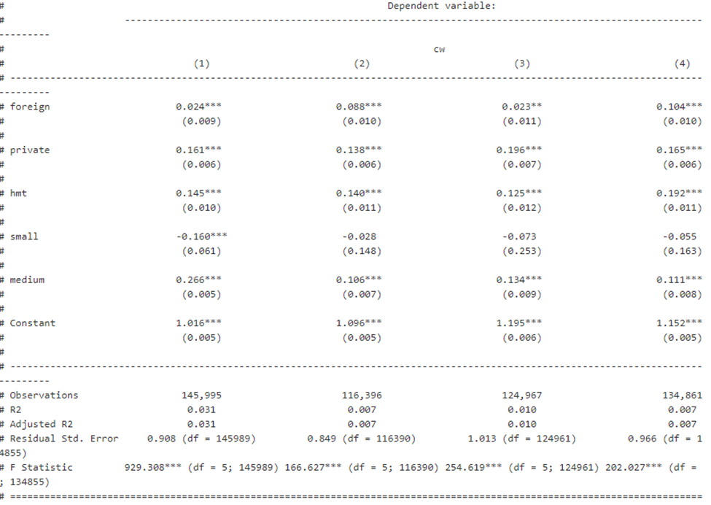

**Table 13**

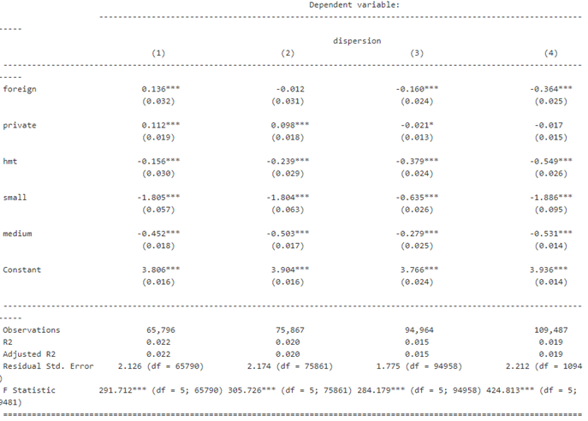

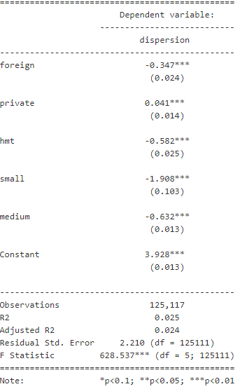

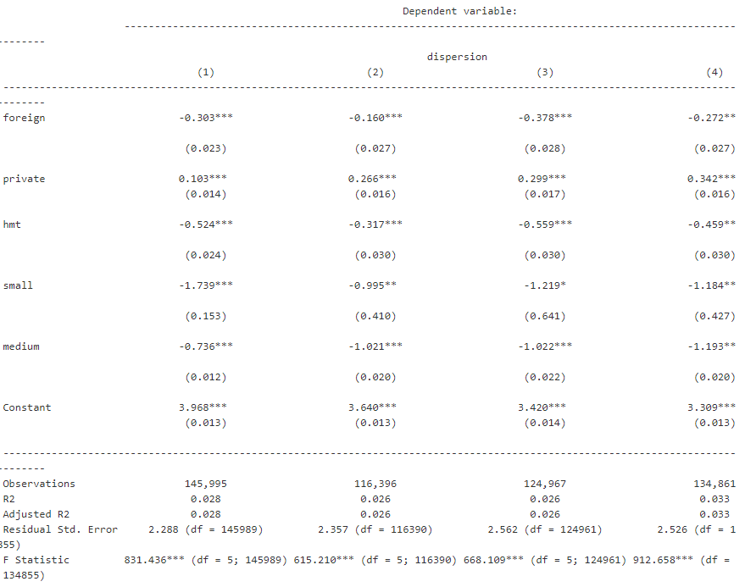

Work Cited

Chang-Tai Hsieh, Peter J. Klenow, “Misallocation and Manufacturing TFP in China and India”, The Quarterly Journal of Economics, Vol CXXIV, Issue 4, November 2009.

V. V. Chari, Patrick J. Kehoe, and Ellen R. McGrattan, “Business Cycle Accounting”, Federal Reserve Bank of Minneapolis, Research Department Staff Report 328, December 2006.

[Diego Restuccia](https://www.nber.org/people/diego_restuccia), [Richard Rogerson](https://www.nber.org/people/richard_rogerson), “Policy Distortions and Aggregate Productivity with Heterogeneous Plants”, Review of Economic Dynamics,  Elsevier for the Society for Economic Dynamics, vol. 11(4), pages 707-720, October 2008.

Huihua Nie, Ting Jiang, and Rudai Yang, “A Review and Reflection on the Use and Abuse of Chinese Industrial Enterprises Database”, World Economy, 2012, no.5.

Chinese Academy of Fiscal Sciences,

[www.chineseafs.org.](http://www.chineseafs.org.)

1. Y: total production unit. Z: productivity. K: total amount of capital. a: capital share. L: labor. P: price. w: wage. R: opportunity cost for capital.
2. The standards are: number of employees less than 8; missing variables for calculation; total capital less than fixed capital or total capital less than non-fixed capital; revenue less than 5 million before 2011 or less than 20 million after 2011; profit margin less than 0.1 % or higher than 99%; paid-in capital less or equal to 0.